**SAE AERO DESIGN REPORT**

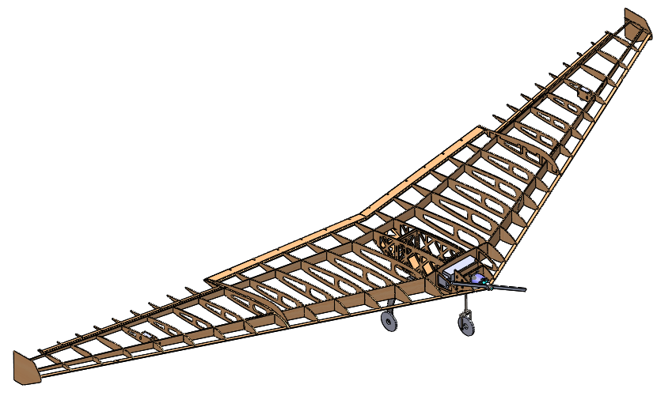

**HOOS FLYING**

University of Virginia

Aero Design Team 2014

Team 006

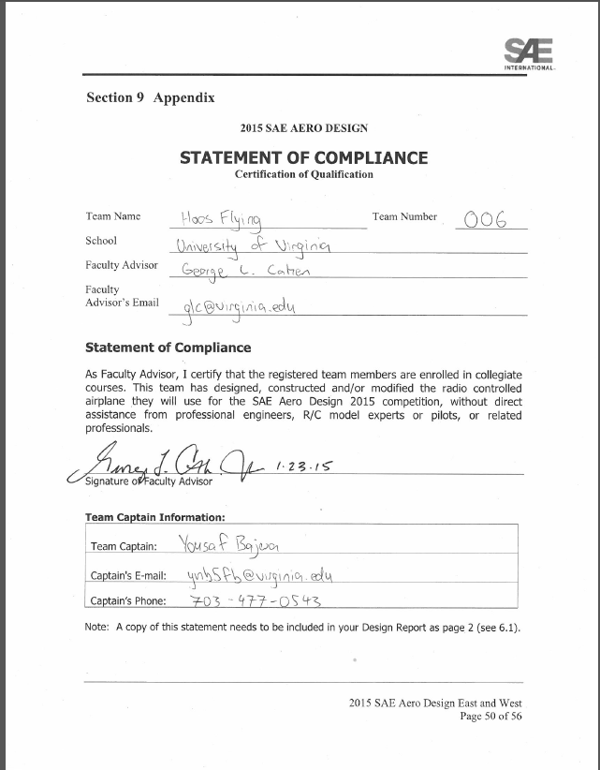

**Table of Contents**

1. DESIGN PROCESS 5

1.1 Design Requirements 5

*1.1.1* *Dimensions and Sizing* 6

1.1.2 *Payload Requirements* 6

*1.1.3* *Propulsion Requirements* 6

1.1.4 Competition Flight Rules 6

1.2 Team Goals and Design Philosophy 7

*1.2.1* *Team Objectives* 7

1.2.2 Design Philosophy 7

1.3 Strategy 7

1.3.1 Team Management 7

1.3.2 Team Organization 8

1.4 Concepts 8

1.4.1 Research and Discussion 8

1.4.2 Previous Years and Competitions 9

1.4.3 Methods and Procedures 9

1.4.4 Design Analysis and Conclusion 10

2. ANALYSIS 10

2.1 Propulsion 10

2.1.1       Engine Selection and Power Limiter 10

2.1.2      Static and Dynamic Testing 11

2.2 Aerodynamic Configuration 12

2.2.1 Airfoil Configuration 12

2.2.2 Planform Selection 14

2.2.3 Payload Bay 15

2.2.4 Winglets and Fences 15

2.3      Stability and Control 15

2.3.1     Pitch, Yaw and Roll 15

2.3.2       Aeroelasticity 17

2.3.3       Center of Gravity 17

2.3.4 Simulation Testing 17

2.4 Aircraft Sizing and Configuration 18

2.4.1     Wing Sizing 18

2.4.2   Servo Sizing 18

2.4.4       Payload Bay Sizing 19

2.4.5     Wheels and Landing Gear 19

2.5 Weight Build up and Manufacturing 20

2.5.1       Material Selection 20

2.5.2       Wing Ribs and Main Spar 20

2.5.3       Payload Bay 21

2.5.4       Manufacturability 22

2.5.5 Landing Gear 23

2.5.6 Aircraft Weight 24

2.5.6 Wheel Design 24

2.5.8       Cost Analysis 25

2.5.8 Schedule 25

2.6      Structural Analysis 25

2.6.1       Payload Bay 25

2.6.2       Main Spar 26

2.6.3     Main Landing Gear 27

2.6.4    Weight Savings 28

2.7      Scoring Analysis 29

2.7.1       Flight Score Analysis 29

2.7.2      Our Strategy 29

2.7.3       Performance Parameters 29

3 INNOVATIONS 30

3.1.1 Construction Method 30

3.1.3       Simulation Testing 30

**Table of Figures**

Figure 1: Gantt Chart 8

[Figure 2: Static Thrust vs. Power Consumption 11](https://d.docs.live.net/3dba5f491bed91ab/Hoos%20Flying/2015%20Design%20Report_HoosFlyingday6.docx#_Toc410075366)

[Figure 3: Dynamic Thrust vs Propeller Power **Error! Bookmark not defined.**](https://d.docs.live.net/3dba5f491bed91ab/Hoos%20Flying/2015%20Design%20Report_HoosFlyingday6.docx#_Toc410075367)

[Figure 4: Coefficient of Moment vs Angle of Attack (degrees). Purple is the curve for E326 and the brown is the curve for E330. 13](https://d.docs.live.net/3dba5f491bed91ab/Hoos%20Flying/2015%20Design%20Report_HoosFlyingday6.docx#_Toc410075368)

[Figure 5: Coefficient of Lift vs Angle of Attack (degrees). Purple is the curve for E326 and the brown is the curve for E330. 13](https://d.docs.live.net/3dba5f491bed91ab/Hoos%20Flying/2015%20Design%20Report_HoosFlyingday6.docx#_Toc410075369)

[Figure 6: Coefficient of Drag vs Angle of Attack (degrees). Purple is the curve for E326 and the brown is the curve for E330. 14](https://d.docs.live.net/3dba5f491bed91ab/Hoos%20Flying/2015%20Design%20Report_HoosFlyingday6.docx#_Toc410075370)

[Figure 7: XFLR5 Planform Trade Study. 24 Degrees (Top), 27 Degrees (Middle) and 30 Degrees (Bottom) 14](https://d.docs.live.net/3dba5f491bed91ab/Hoos%20Flying/2015%20Design%20Report_HoosFlyingday6.docx#_Toc410075371)

Figure 8: Stability coefficients obtained using XFLR5 16

Figure 9: Directional Stability due to Wing Sweep 16

Figure 11: RealFlight Model 17

Figure 10: Servo Torque Calculations 18

**Table of Tables**

Table 1: Design Requirements 5

Table 2: Pugh Chart for Aircraft Configuration 9

Table 3: Wing Sweep and Statics Stability 15

Table 4: Hand Caculated Static Stability Parameters 16

# DESIGN PROCESS

**Objective**

*The goal for the 2015 competition is to successfully take off, complete a full flight path, and land a model airplane that matches all dimensional and rule restrictions set by SAE Regular Class guidelines. Under these restrictions, teams compete to carry the most weight summed across every flight round.*

* 1. Design Requirements

|  |  |
| --- | --- |
| **Topic** | **Specification** |
| Dimensions | The maximum combined length, width, and height of the aircraft is 175 inches. |
| Weight | The aircraft cannot weigh more than 55 pounds with payload. |
| Material | Fiber-reinforced plastics (FRP) or lead may not be used in the design or payload. |
| Motor | A single electric motor must be used. |
| Takeoff | The aircraft must take off in 200 feet within a three minute limit. |
| Landing | The aircraft must land within 400 feet. |
| Batteries | The aircraft must be powered by a commercially available, 6 cell, Lithium Polymer battery with a minimum rating of 3000 mAh and 25C. |
| Red Arming Plug | A red arming plug must be included in the circuitry and must be located at 40% to 60% of the aircraft length from the propeller and must be on top of the fuselage and external of the aircraft surface. |
| Payload | The payload must be fixed in flight and loaded and unloaded under 1 minute. |
| Payload Bay | A single, closed payload bay must be incorporated and must be 4 x 4 x 10 inches. |

Table : Design Requirements

* + 1. Dimensions and Sizing

The competition rules allow a maximum combined length, width, and height of 175 inches. The rules define the length as the maximum distance from the front to the aft, with the width as the maximum distance from wingtip to wingtip, and the height as the maximum distance perpendicular from the ground to the highest part of the aircraft excluding the propeller. The aircraft may not weigh more than 55 pounds with payload.

* + 1. Payload Requirements

The payload bay must a closed box with the dimensions 4 x 4 x 10.125 in.  There may only be one payload bay, and the payload must consist of a homogeneous mass and the support assembly.  Additionally, the payload bay and payload must be fixed to the airframe to prevent shifting during flight.  The aircraft must be airworthy and structurally sound with and without the payload.   The only penetrations allowed through the walls of the box are for a removable support assembly.

* + 1. Propulsion Requirements

The specific make or model of the electric motor used is unrestricted. Competition rules only allow a single motor on the aircraft. The aircraft must use the SAE 1000 watt power limiter V2, supplied by Neumotors. The battery used must be a commercially available 6 cell (22.2 V) Lithium-Polymer battery with a minimum capacity of 3000 mAh and a minimum C-rate of 25C.

### ***Competition Flight Rules***

For a successful take-off, the airplane wheels must leave the ground in under 200 ft. within 3 minutes.  The aircraft must complete a 360° circuit after taking off. For a successful landing, the aircraft must touch the ground within the 400 ft. designated landing zone.

## Team Goals and Design Philosophy

* + 1. Team Objectives

The team’s objective this year was to be creative.  With the design rules being relatively unchanged, the team decided to explore new configurations.  In previous years we developed conservative designs to ensure reliable performance. This year, we decided to use our experience to bring to life ideas we previously deemed too radical. Our objective was to be innovative in our design yet cautious in our implementation.

### ***Design Philosophy***

This is the eighth year that Hoos Flying at the University of Virginia will attend and compete in the SAE Aero Design East competition.  Over the years, the team has steadily experimented with and refined traditional monoplane designs. This accumulated experience allowed us to successfully earn second place in the 2013 East competition and third place in the 2014 East competition.  This year we diverged from our traditional design, striving for challenge in an unconventional route. In the words of Orville Wright, “If we worked on the assumption that what is accepted as true is really true, then there would be little hope for advance”.

## **Strategy**

### ***Team Management***

From past experience, the team developed a generalized idea of how much time should be allotted to specific aspects of the design process, accounting for the obstacles and time delays usually encountered. To be sure that none of these aspects were ignored because of lack of organization, forgetfulness, or time constraints, a Gantt chart was designed to break down tasks throughout the academic year.

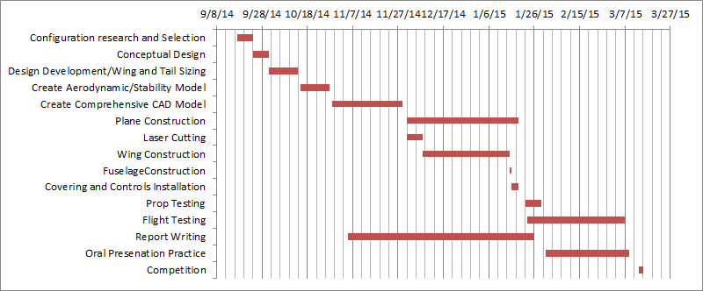

Figure : Gantt Chart

### Team Organization

The team formed three subgroups: aerodynamics, structures, and R&D. Members were assigned to subgroups taking into consideration individual’s particular strengths and interests in certain aspects of the plane’s design. A more experienced member, the subgroup leader, was responsible for overall management and success of their respective subgroup.  The aerodynamics group was responsible for developing aerodynamic and stability analysis.  The structures team was responsible for producing a comprehensive CAD model as well as simulating and analyzing structural integrity.  The R&D team was responsible for plane construction, motor testing, and laser cutting.

## Concepts

### Research and Discussion

Every year, the team begins by considering several different aircraft configurations. The main ideas proposed this year included the traditional monoplane, a lifting-canard configuration, a tandem-wing configuration, a biplane, and a blended-wing body design. The parameters used to assess these configurations included aerodynamic performance, reliability, and ease of construction. Ratings were given based on past experience and research into the advantages and disadvantages of these configurations.

|  |  |  |  |  |
| --- | --- | --- | --- | --- |
| **Figures of Merit** | **Weight** | **Mono-**  **plane** | **Tandem Wing** | **BWB** |
| Ease of Building | 0.5 | 0.5 | 0 | 1 |
| Lift | 1 | 1 | 1 | 1 |
| Drag | 1 | 0 | 0 | 1 |
| Flight Char. | 0.5 | 1 | 0.5 | 0 |
| Past Experience | 0.5 | 1 | 0 | 1 |
| **Total** |  | **2.25** | **1.25** | **3** |

Table : Pugh Chart for Aircraft Configuration

The weight given to each parameter reflects our intent to experiment and innovate with this year’s design. Our research showed that blended-wing body style aircraft can theoretically provide superior lift through increased surface area while minimizing structural weight. In particular, the Northrop YB-49 served as the inspiration for our design. The team therefore decided to proceed with a blended-wing body configuration.

### Previous Years and Competitions

In the 2012 competition, our team focused on a conservative design with a plywood fuselage.  We settled on a high wing monoplane with a boom tail made of bamboo.  In 2013 we further developed the monoplane configuration. We kept a similar wing structure but replaced the plywood fuselage with a balsa truss system.  This design required a very intensive build process, but carried us to second place despite stability issues with steering and landing gear.  In 2014, we scaled our previous design to the new design constraints, and implemented an electric motor for the first time. The 2015 blended-wing body deviates significantly from our previous designs.

### Methods and Procedures

The team spent several weeks brainstorming and debating different conceptual designs, ultimately voting to pick the final one.  Once we decided on a preliminary conceptual design, we utilized several software packages to develop the detailed design.  XFOIL was used for airfoil selection. XFLR5 was used to test aerodynamic models, and RealFlight 5.0 was used to evaluate flight experience and controllability. Matlab code was written to evaluate some aircraft performance parameters. Solidworks was used to develop a CAD model for the majority of the aircraft. Its FEM solver was used to test the structural integrity of individual components such as the landing gear, wing spar, and fuselage. DXF files generated from the CAD model were used to laser cut several aircraft components and perform simulation testing. Finally, the CAD model was refined, final parts were laser cut, and the final configuration was manufactured over the course of approximately three weeks.

* + 1. Design Analysis and Conclusion

This year’s design emphasized innovation and experimentation.  We achieved superior lift with the large wing surface area of a blended wing-body design. Along the way, the team encountered several design issues. Our laser cut airframe, however, allowed us to keep build times short and minor modifications easy to implement. With improved payload capacity, we fully expect our design to carry enough payload to maintain our standing as one of the top teams in SAE AeroDesign East.

# ANALYSIS

## Propulsion

### 2.1.1       Engine Selection and Power Limiter

Satisfied with the performance of the Hacker A40-8L motor last year, we decided to continue with the same brand. Given the relatively low airspeeds and rates of climb experienced during the competition, the team wanted a motor that could efficiently turn higher diameter propellers. The Hacker A50-16S V3 met our design requirements best. With a peak power draw of 1200 Watts, it was ideal for our configuration. Considering the power limiter’s 1000 watt cut off point, our approach this year was to limit a more powerful motor rather than push a smaller motor to its maximum capacity.  The Hacker A50-16S V3 accomplished this and provided our aircraft with significantly more thrust.

### 2.1.2      Static and Dynamic Testing

The team started with the recommended speed controller and power limiter setup for preliminary motor analysis. The setup included the Hacker A50-16S V3, the Hacker X-70 ESC, and a Thunder Power RC 3300 mAh 6S-45C battery, Neumotors SAE Limiter V2, and a Turnigy Watt Meter. The team decided to test two larger propellers, an APC 17x8E, and an APC 17x10E propeller, both larger than the APC 15x8E propeller tested last year.

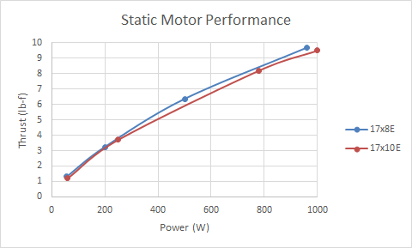To optimize engine performance, the team recorded data concerning peak thrust and power consumption, along with the power consumption at lower throttle settings. The following data was recorded at static conditions for our chosen propellers:

Figure : Static Thrust vs. Power Consumption

Though the peak thrust and power consumption for both propellers were similar, the 17x8E had favorable performance over a range of throttle settings. However, the 17x10E propeller hovers very near the 1000W limit at full throttle, risking engine cut off at full throttle. The 17x8E propeller provides the pilot superior control due to decreased throttle sensitivity and lack of risk of a shut-off, and was selected for the final design.

To attain a dynamic model of the engine as it travels through the air, we repeated the test with the propeller facing oncoming wind. The wind was produced by placing the experimental set up behind the outlet of a wind tunnel, then setting the wind speed to the plane’s estimated takeoff speed. The results show that as the wind speed increases, the thrust of the propeller decreases, but the power consumption remains constant within experimental error.

We concluded that as we increase our speed, our motor will have to work harder to keep the thrust value constant. However, we do not expect this loss of thrust to be a concern. Once the plane is airborne, the airspeed will be great enough to maintain altitude and control.

## Aerodynamic Configuration

### 2.2.1 Airfoil Configuration

While the airfoils of both the original YB-49 and the RealFlight6.5 model were known, we decided to go with Eppler series of airfoils due to past success with them as well as to better address our design objectives. Due to the lack of a tail, the moment coefficient curves had to be such that the aircraft could remain statically stable in flight and produce enough rotation on takeoff.

In blended-wing body design, planform geometry can overcome problems from improper airfoil selection. However, excessive sweep and twist contributes to performance losses in the form of increased induced drag and poor stall characteristics. Our choice of airfoils have a reflexed camber line to limit the variation in moment coefficient with angle of attack, and to therefore limit the amount of twist and sweep incorporated into the wing.

The root airfoil was defined as the Eppler 326 while the wingtips as the Eppler 330 and entire wing is a linear transition between these two airfoils.

Our choice of two separate airfoils introduces a degree of aerodynamic twist due to the different zero-lift angles of the airfoils, further reducing the required geometric twist. These two airfoils both have positive moment coefficients throughout our aircraft’s operational range.

Figure : Coefficient of Moment vs Angle of Attack (degrees). Purple is the curve for E326 and the brown is the curve for E330.

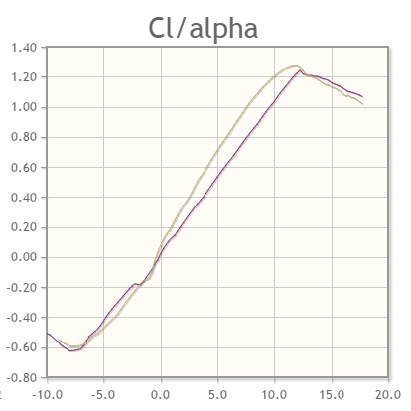XFOIL, a VLM based CFD solver, revealed the following curves:

Figure : Coefficient of Lift vs Angle of Attack (degrees). Purple is the curve for E326 and the brown is the curve for E330.

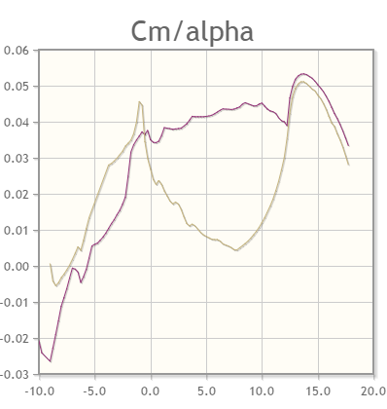

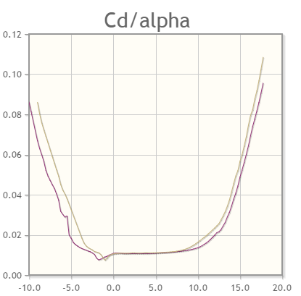

Figure : Coefficient of Drag vs Angle of Attack (degrees). Purple is the curve for E326 and the brown is the curve for E330.

Other airfoils considered were the MH series of reflexed airfoils, but they provided only marginally improved performance over this configuration. Because they tended to be very thin, however, the linear transition to the tip would necessitate either structural reinforcement or a more dense material choice.

Figure : XFLR5 Planform Trade Study. 24 Degrees (Top), 27 Degrees (Middle) and 30 Degrees (Bottom)

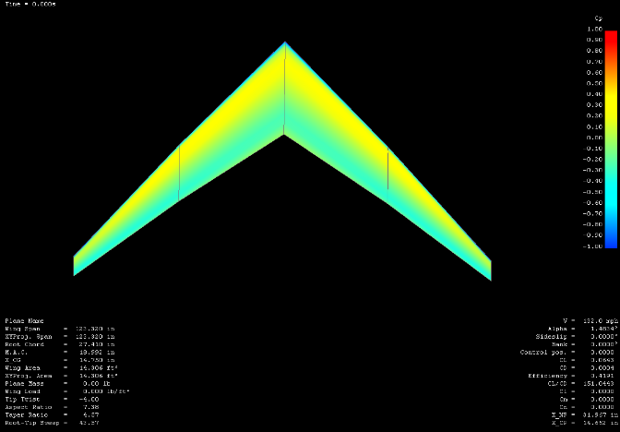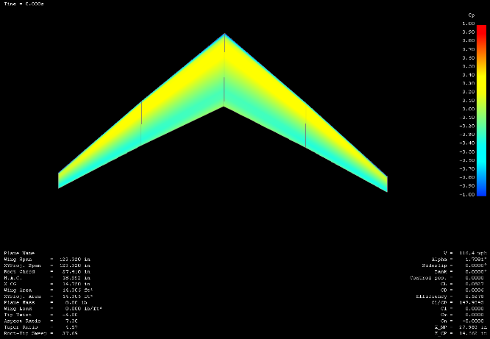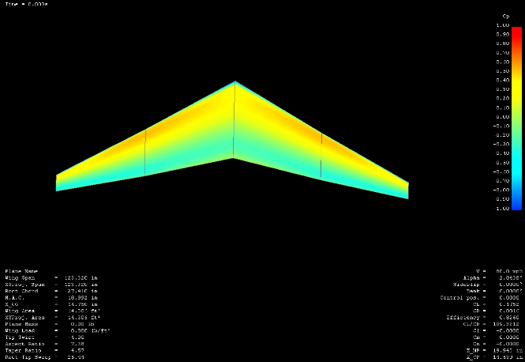

### 2.2.2 Planform Selection

The team used data from XFLR5 to optimize planform shape. The primary variable we tested through this program was static stability margin as a function of wing sweep. As wing sweep increases, the aircraft’s neutral point is pushed back and the resultant static stability margin improves. However, more sweep results in less wingspan due to the dimensional constraints specified by the rules.

To find a balance between sweep and static stability margin, we tested several configurations within XFLR5.

|  |  |  |  |
| --- | --- | --- | --- |
| Wing Sweep | Neutral Point, inches | Static Stability Margin | Wing Area, ft^2 |
| 24° | 17.582 | 14.92% | 14.3 |
| 27**°** | 19.943 | 27.3% | 13.5 |
| 30**°** | 21.855 | 37.4% | 12.9 |

After testing wing sweep for a range of angles, we determined 24° to be the minimum amount of sweep needed to maintain our goal static stability margin of 15%.

Table : Wing Sweep and Statics Stability

### Payload Bay

It was important to reduce the cross sectional area of the payload bay to avoid blocking the thrust from the propeller. We accomplished this by tapering from the full width of the payload bay, down to 10% of the propeller diameter at the firewall. The payload bay is integrated into the wing, minimizing cross sectional area and reducing aerodynamic inefficiencies. To further streamline the payload bay, a 25° taper blends it into the trailing edge of the airframe.

### Winglets and Fences

The primary purpose of winglets is to reduce wingtip vortices, which are caused by pressure differences between the upper and lower surfaces of the wing and increase induced drag. However, the main benefit of winglets for our design is their ability to improve lateral stability. Our winglets are located 17.1 inches behind the aircraft’s empty CG. If the aircraft is side-slipping at its takeoff velocity at 45 degrees, the combined moment of the winglets totals about .5 lb-ft.

This has a positive impact on the aircraft’s lateral stability. XFLR5 stability analysis revealed the following improvements of damping coefficients.

|  |  |
| --- | --- |
| Dutch Roll Mode | Damping Factor, ς |
| Without Winglets | .512 |
| With Winglets | .134 |

To further improve lateral stability, the team added wing fences to limit span wise flow and improve stall characteristics.

## 2.3      Stability and Control

### 2.3.1     Pitch, Yaw and Roll

Though the team’s primary focus was maximizing surface area, stability concerns led us to make several design modifications. In order to improve static stability margin, the team introduced -4° of geometric twist into the wing. This value was determined from the empirical relations published by Dr. Martin Hepperle.

Because we have introduced aerodynamic twist through our selection of airfoils, we did not have to make the angle very large. We found our addition of winglets and wing fences to provide sufficient lateral stability.

XFLR5’s built-in stability analysis was used to calculate relevant stability coefficients for longitudinal, yaw, and roll stability. The program calculated the values shown in Figure 8.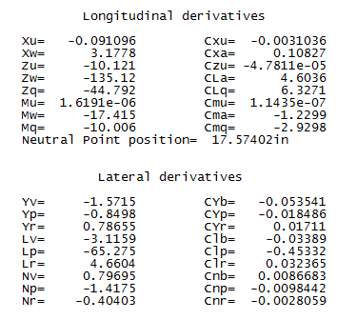

Figure : Stability coefficients obtained using XFLR5

|  |  |
| --- | --- |
| Stability Margin | 14.92% |
| Neutral Point *from Datum* | 17.57 ***in*** |

Table : Hand Caculated Static Stability Parameters

We iterated variables such as wing sweep until we had reached our desired level of longitudinal stability of 15%. The program calculated a stability margin of 14.92% with a sweep of 24°***.***

Yaw stability was primarily a function of wing sweep and winglet size. Wing sweep inherently improves directional stability, and the winglets serve to improve it further.

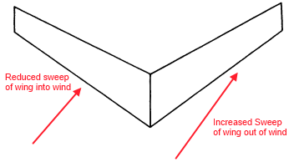

Figure : Directional Stability due to Wing Sweep

Though the wing did not have any dihedral, we achieved dihedral effect through our low center of gravity, 24° wing sweep angle, and -4° of wing twist.

XFLR5 also provided the following values for damping factors of different flight modes:

|  |  |
| --- | --- |
| Mode | Damping Factor, *ς* |
| Phugoid | .004 |
| Short Period | .350 |
| Dutch Roll | .134 |

### 2.3.2       Aeroelasticity

In past years, our team has created wings similar in structure, camber, and thickness. Since these have shown considerable damping of structural deformation, we have assumed that the dynamic aeroelastic effects will be negligible. Our analysis assumes a rigid body.

### 2.3.3       Center of Gravity

The team targeted a static stability margin of 15%. Through XFLR5 iteration, it was set to 14.92% of the mean wing chord, with the neutral point and center of gravity positioned at 17.57 and 14.75 in from the datum, respectively. We placed the payload bay slightly ahead of the center of gravity to maintain stability during loading. The payload will assist in providing roll stability when turning.

* + 1. Simulation Testing

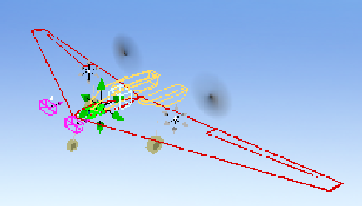

Figure : RealFlight Model

Two years ago during the briefing and opening ceremony, the team received a free copy of Realflight’s R/C simulator package. This was a great resource for new team members interested in learning to fly but concerned about crashing a real plane. The simulator was also a useful modeling tool for this year’s design. Using the simulator’s built-in editing capabilities, a model of the Northrop YB-49 was modified to reflect the specifications of our plane including airfoil, incidence angle, dihedral, control surface sizing, CG location, and amount of payload. This enabled testing of the plane’s stability and handling performance before attempting a maiden flight, and provides the pilot with an accurate model to practice flying leading up to the competition.

## 2.4 Aircraft Sizing and Configuration

### 2.4.1     Wing Sizing

With a blended-wing body configuration, we wanted to allocate the maximum amount of the available 175 inches of dimension available to wingspan. The height of the payload bay (4 inches), landing gear and diameter of the wheels (6 inches), and the top of airfoil (3 inches) suggested that a height of approximately 13 inches was required. From intuition, the team knew that the length of the aircraft would require approximately 36 inches due to the center chord length and the sweep of the wing. Therefore, we were left with a wingspan of 123 inches with 3 inches extra for the addition of winglets and wing fences.

### 2.4.2   Servo Sizing

The team assumed that the maximum load on the servo will occur when a control surface is fully deflected. We assumed the angle of incidence of the control surfaces is 0°. With zero angular velocity and acceleration, the following equation can be used to predict servo loads at different deflections.

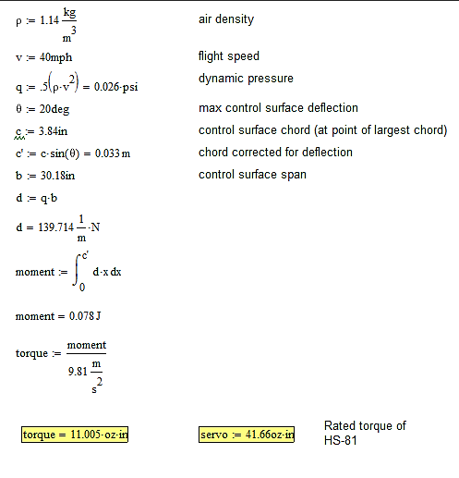

Figure : Servo Torque Calculations

The selected Hitec HS-81 micro servos can deliver this torque with a safety factor of 3.79.  
2.4.3       Control Surfaces and Winglets

Due to the absence of a tail section, the blended-wing body required elevons in place of the aileron/elevator combo traditionally used. The elevons are located on the outboard section of the wing to ensure ideal lateral moments required for effective attitude control and to prevent flow disturbance on the inboard sections of the wing. The equation demonstrates the method used to acquire an elevon effectiveness value of 0.438 through the following formula.

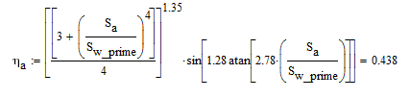

Equation : Elevon Effectiveness Calculation

The vertical dimensions of the winglets were sized based on the dimensions left to us. Additional considerations were given to provide enough height to fit the 4” team number onto the winglets.

### 2.4.4       Payload Bay Sizing

We designed the payload bay to minimize the frontal cross sectional area. This was constrained by the rules requiring the payload bay volume be 4 x 4 x 10 in. In order to allow space for additional support structure, spar attachments, landing gear mounting, and servo wiring, the payload bay was blended into the wing.

### 2.4.5     Wheels and Landing Gear

The landing gear configuration was designed with the primary goal of providing clearance for the large propeller diameter. Due to the height of the fuselage and the large wingspan, the team chose a wide landing gear configuration to provide stability and minimize roll throughout the take-off and landing sequences. For the wheels, we used high precision ABEC 9 bearings to minimize wheel drag on the ground during take-off. Minimizing drag without sacrificing wheel traction proved vital in a successful gear design.

## 2.5 Weight Build up and Manufacturing

### 2.5.1       Material Selection

For material selection, CES EduPack 2014’s level 2 material database was used to compare the properties of basswood, plywood, and balsa for each aircraft component. We chose to focus on these materials because they can be laser cut easily, significantly reducing build time. Our main goal was to minimize aircraft weight while maintaining strength and low build time. Therefore, in our CES analysis we chose the following performance indices for a beam in bending: E1/2/ρ for a stiff, light beam, and σy2/3/ρ for a strong, light beam. In order to apply the performance index relation, the team used a line of slope two in Figure 13 and a slope of one and a half in Figure 12.

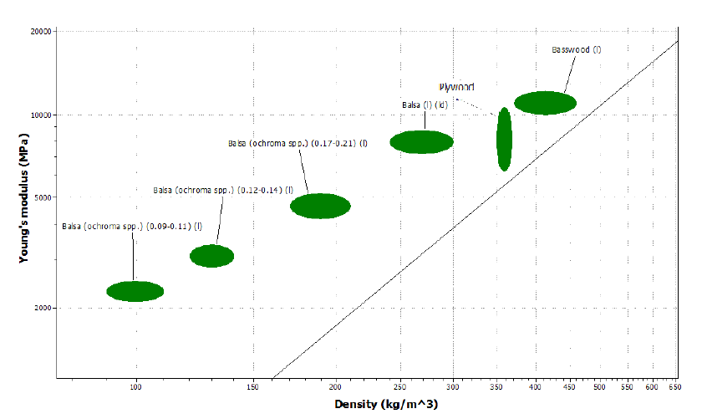

Figure : Stiffness vs Density Plot for Different types of Balsa and Basswood

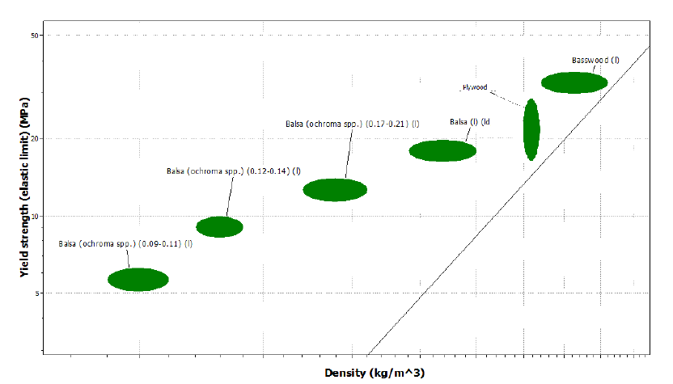

Figure 13: Stiffness vs Density Plot for Different types of Balsa and Basswood

### 2.5.2       Wing Ribs and Main Spar

When the wing’s components are modeled as a beam in bending, it is an accurate representation of the stresses induced by the dominant forces of flight. For the main spar, the central structure was the anchor point and wing lift was the loading mechanism. Ribs were modeled as being fixed to the main spar, with wing lift as the loading mechanism once again.

As shown in figures 12 and 13, balsa was the ideal material when considering strength, stiffness, and weight in terms of performance index. Wing ribs make up most of the wing’s mass, so our choice of balsa minimized the wing’s weight. Balsa was also used for leading edge sheeting. We could not buy a prefabricated leading edge because our wing is too thick, so we created one using balsa sheeting. This was necessary due to the complexity of manufacturing a small leading edge.

Because the main spar is subjected to much higher loading than individual ribs, we decided to avoid using balsa because of its relatively low yield strength of 1.9 ksi. Plywood performed only marginally worse than balsa in our material analysis, but along with its higher density comes its significantly higher yield strength of 4.35 ksi. Plywood also happens to be widely available at local hobby shops, so the team decided to use it for the main spar.

### 2.5.3       Payload Bay

The payload bay is the backbone of the aircraft, bringing all components together in addition to securing the motor. Upon takeoff and landing, the airframe experiences substantially higher bending moments. In flight these bending moments continue along with added torsional effects. The wing twists the structure back and forth, easily leading to a fatigue failure if the material is not stiff enough.

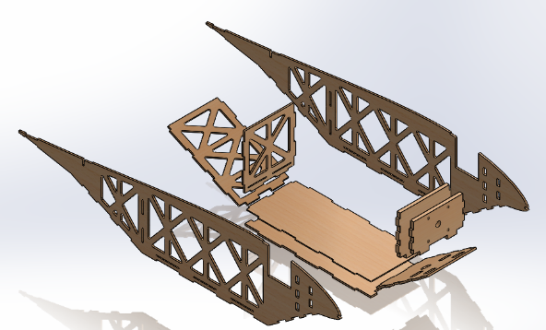First, we eliminated balsa as a choice because it would not be strong enough to handle the forces experienced by the payload bay, despite its superior specific strength.  
Considering all these factors, basswood was our first option, but we later decided on plywood because the grain travels in multiple directions, preventing shearing. It would be able to handle the multi-directional loadings we expected much better than basswood. The team decided to use .125 in thick plywood for the primary structure, and .25 inch thick plywood for the firewall.

### 2.5.4       Manufacturability

Using balsa and plywood for nearly every structural element of the airframe significantly improved manufacturability. To maintain strict quality control and simple manufacturing, we used a laser cutter to cut as many components of our aircraft as possible. Furthermore, a blended-wing body design choice reduces the number and complexity of the pieces required, decreasing construction time.

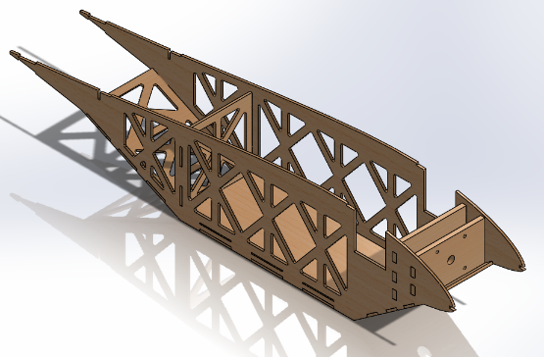

Figure : Exploded Payload Bay

Figure : Payload Bay

One of our primary concerns was aircraft survivability. Through our use of the laser cutter, the aircraft essentially came to be a 3D puzzle where any component could be replaced easily if it needed to be. Epoxy resin held together the structural components of the payload bay as well as its connection to the main spar. We found thin and gap-filling CA glue sufficient for the rest of the airframe.

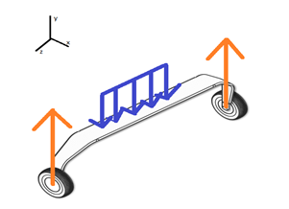Though the laser cutter significantly reduced manufacturing time, we did hit a problem which took many man-hours to resolve. The bed of the truck used to transport the plane could not accommodate the plane with its 10 foot wingspan, so we needed to break apart the wing into individual components. This forced us to cut the main spar where the wing tips would join the center body. Luckily, this joint is very strong and it is unlikely that it would be damaged in the event of a crash. Because the plane was designed as three individual pieces, team members could work on individual portions of the plane simultaneously and reduce overall build time.

Figure : Landing Gear Modeled as a Beam in Bending

### Landing Gear

The purpose of the landing gear is to maximize absorption of energy upon landing.   Upon touchdown, the leaf spring can be modeled as a beam in bending due to the weight of the fuselage and the two forces from the wheels touching the ground as shown in Figure 16.

We used CES EduPack again to perform material analysis.  The constraints were: no plastic deformation (σy > σmax = 5.5*107 Pa), high degree of machinability, and a minimum fracture toughness of 107 Pa*m0.5.  The indices used were:  M = σy2/(E*ρ)  (Maximum Stored Elastic Energy Per Unit Weight),  M = rho (Minimize Weight),  M = E  (Maximum Stiffness). The materials with the highest performance index scores are the best fit for our design.

Our material analysis revealed CFRP to be the material of choice for a landing gear. Since CFRP landing gear is commercially available, we integrated it into our design.

### 2.5.6 Aircraft Weight

|  |  |  |
| --- | --- | --- |
| **Weight Breakdown** | | |
| **Part** | Weight (oz) | Distance from nose tip (in) |
| **Centerbody** | 40 | 15.3 |
| **Wingtips** | 22.8 | 21.5 |
| **ESC** | 2 | 5.9 |
| **Receiver** | 0.5 | 5.9 |
| **Nose Servo** | 1.5 | 5.9 |
| **Battery** | 18.2 | 5.9 |
| **Propeller, spinner, and motor** | 18 | 2.185 |
| **Nose Wheel** | 1.1 | 4.85 |
| **Landing Gear** | 2.4 | 13.56 |
| **Rear Wheels** | 2.2 | 13.56 |
| **Nose Gear Spring** | 3.5 | 4.87 |
| **Elevon Servos** | 3 | 25.46 |
| **Empty Weight** | 115.7 | 11 |
| **Max Payload** | 528 | 9.375 |

Table : Weight Breakdown

* + 1. Wheel Design

To reduce wheel rolling resistance and drag in flight, we machined an aluminum hub out of 0.25 inch aluminum plates to resist deformation and create a thin wheel profile. The team selected a 3 inch diameter based on commercially available wheels for similarly sized aircraft. SBR rubber was selected for the tires because it is commonly used as a synthetic tire material, to provide a high coefficient of friction and prevent the aircraft from drifting to the side on takeoff. To seat the rubber tires, a 0.125 inch wide, 0.18 inch deep groove was machined about the circumference of the aluminum disk to prevent the tire and hub from separating when subjected to impact loads on landing. We selected ABEC rated deep groove ball bearings for their ability to support both axial and radial loads and further reduce rolling resistance. Three such wheels were manufactured: one for the nose gear and two for the main landing gear.

### 2.5.8       Cost Analysis

|  |  |
| --- | --- |
| **Component** | **Cost** |
| **Propellers** | $30.00 |
| **Motor** | $190.00 |
| **ESC** | $110.00 |
| **Power Limiter** | $50.00 |
| **Battery** | $160.00 |
| **Servo Motors** | $60.00 |
| **Balsa Wood** | $260.00 |
| **Plywood** | $40.00 |
| **Ultracote** | $110.00 |
| **Rear Landing Gear** | $18.00 |
| **Nose Landing Gear** | $29.00 |
| **Wheels** | $1.00 |
| **Total** | $1058.00 |

Table : Manufacture Cost Analysis

With any design project it is important to efficiently use available resources. Even though the plane from last year was severely damaged, the team was able to save the radio equipment and ESC for this year’s plane. The team focused on consolidating the raw materials needed for construction.  This way, excess materials from one part of the plane could be used in construction of another.

2.5.8 Schedule  
The manufacturing began in late November 2014 and terminated in mid-January 2015, resulting in two planes. The first stage of construction was comprised of laser cutting the parts of the plane from the developed CAD files. Afterwards, these parts were used to construct the center body. Once the center body was complete, the wingtips were built and attached to the body. As the final step, the Ultracote was used to cover the surfaces of the plane.

## 2.6      Structural Analysis

### 2.6.1       Payload Bay

To test the structural integrity of our payload bay, we utilized SolidWorks’ FEA solver. To simulate the forces on the fuselage, we added fixed geometry constraints on the point where the spar meets the payload bay. This accurately simulates the primary forces acting upon the center body. The payload is then simulated by a distributed load on the payload floor.

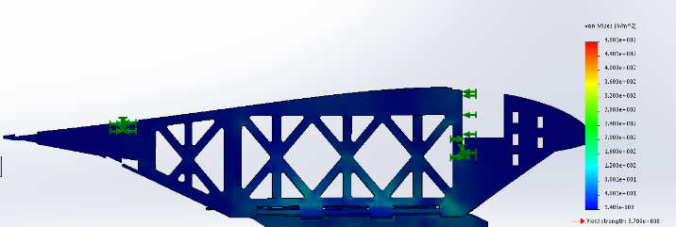

Figure : Von Mises Stress according to Solidworks Static Simulation

The force we used in this model is the equivalent to a 20 lb payload experiencing a 3g turn. After running the simulation, the fuselage was found to have a minimum factor of safety of 1.9 with the largest stress concentrations located a short distance from the landing gear mounting point. This can be seen in the factor of safety plot seen above. The simulation is supported by the empirical data gathered after the construction of the fuselage.

### 2.6.2       Main Spar

We tested the structural properties of the wing spar with the SolidWorks FEA Solver. The spar was isolated from the rest of the wing and modeled in the program. The pink vectors represent a distributed loading upon the main spar. The magnitude of the pressure distribution and its variation was calculated using the pressure coefficient data outputted from XFLR5. The data revealed the pressure distribution to be relatively linear. Under this assumption, the magnitudes of the pressures were implemented into five separate zones on the main spar.  The center portion of the spar was subjected to 5 lb of force, linearly diminishing to 1 lb at the wing tip. The green markers at the center of the spar represent the pinned boundary condition where the payload bay meets the wing.

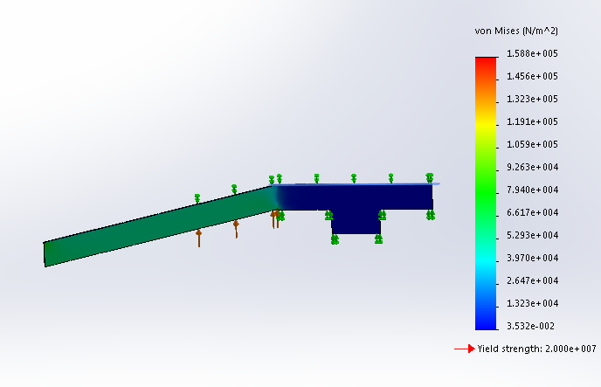

Figure : Von Mises Stress on the Main Spar according to Solidworks Static Simulation

Under these loading conditions, SolidWorks outputted the Von Mises stress distribution as shown in Figure XX. The Von Mises failure criterion demonstrates the effectiveness of the main spar. Clearly, there exist significant stress concentrations at the joint in the main spar. In order to reinforce this joint, metal brackets were used to connect the spars while maintaining the angle between them. The entire connection was then coated with 24-hour epoxy to make sure it can handle the torsional forces it will be subject to. Our spar design will provide ample stiffness to the wing while keeping internal stresses to reasonable levels.

### 2.6.3     Main Landing Gear

Considering the 3 point bending moment that occurs upon landing, a leaf spring shape was chosen this year to efficiently absorb impact loading. The leaf spring was sized to provide adequate ground clearance for the propeller, as well as enough tip clearance to allow for aircraft rotation on takeoff. The landing gear was bolted to the payload box with washers which would distribute the load over the mounting point.  Our rear landing gear was tested in a static loading stress analysis simulation in Solidworks.

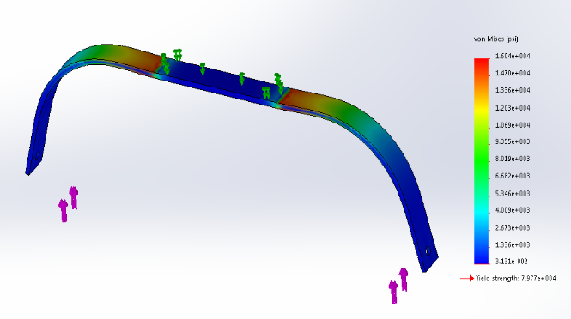

Figure : Von Mises Stress on the Landing Gear according to Solidworks

A pressure force distribution of 60 lbs was applied over the 4 in^2 area of the landing gear where the fuselage made contact.  The places where the wheels are mounted to the landing gear were simulated as fixed points. Our stress analysis revealed that although the loading on the landing gear would be relatively high, hard landings are survivable.

### 2.6.4    Weight Savings

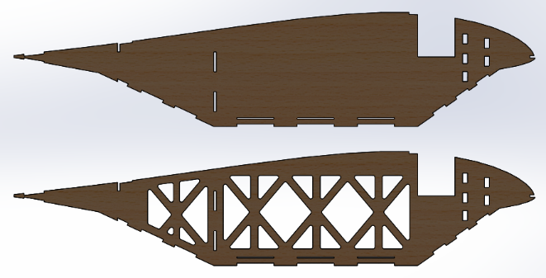A flying wing naturally lends itself to a lightweight structural configuration. Without a tail or even a distinct fuselage, a flying wing can be made substantially lighter than a traditional aircraft. While the weight of our motor, propeller, battery, servos, and wiring was essentially a fixed value at about 2.7 pounds, the rest of the aircraft was kept as light as possible. In choosing our materials, weight was one of the primary considerations. Our choice of balsa for the ribs and plywood for load-bearing components results in a sufficiently tough yet lightweight aircraft.

Figure : Truss Structure Implemented In order to save on weights

We took a minimalist approach in choosing a structural layout for the aircraft by having every component serve multiple roles. The spar was designed to serve as a bulkhead for the payload box, the firewall doubled as a mount for the nose gear, and the payload floor was built to accommodate the landing gear. Weight was further reduced by cutting out material wherever possible. The weight of each rib was halved by cutting out extra material, and a truss structure provided adequate stiffness for the payload box while reducing its weight significantly.

Lastly, a lightweight carbon fiber landing gear along with milled aluminum wheels provided a very robust main landing gear configuration which came in at just .26 pounds.

The plane came in at about 7.2 pounds and is the lightest aircraft we have ever entered into competition.

## 2.7      Scoring Analysis

### 2.7.1       Flight Score Analysis

The equations below show the formula used to calculate the total flight score.

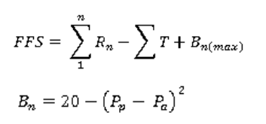

Equation : Flight Score Equation

Here, Rn is the payload weight carried, Pp is the predicted payload, Pa is the actual payload, and Tis the penalty points.

2.7.2      Our Strategy  
To maximize the flight score, it is important to pass inspection without penalties and successfully fly each round with the maximum predicted payload. There is no benefit to flying with more than the predicted payload. Points will be lost through the bonus if the predicted payload and the actual payload deviate by more than 4 lbs.  Durability and consistency is especially vital to maximizing the flight score considering the added summations.

2.7.3       Performance Parameters  
The goal of the competition is to carry as much payload as possible, while taking off within 200 feet. This necessitates a high lift and lightweight design. Payload prediction and optimization was accomplished through drag and aerodynamic analysis through a MATLAB script. At standard conditions, this produced a maximum attainable take off speed of 88 ft/s and a maximum combined weight of 41 lbs using the standard lift equation and established airfoil characteristics.

This equation, however, doesn’t factor in takeoff distance or the empty weight of the plane itself. Thus, payload capacity was recomputed using a conservative form of the takeoff distance formula:

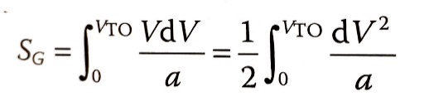

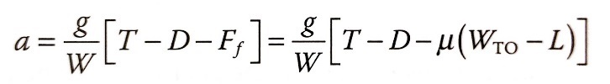

Equation : Take of Distance Approximation

In matching the 200 ft takeoff distance, limit and drag calculations, as well as measured thrust and rolling friction data, we determined a maximum payload of 33 lbs at 53.8 ft/s under standard conditions. Air density factors linearly into payload prediction, as seen in the payload prediction graph under Appendix A.

# 3 INNOVATIONS

### 3.1.1 Construction Method

In order to allow for quick, efficient assembly, the team adopted a 3-D puzzle construction method. Rather than starting building from the very bottom of the plane and slowly reaching the top throughout assembly, major structural components, containing tabs and holes which fit snugly into one another, were pieced together. Assembling in this way allowed the team to first focus on constructing the major frame of the plane before focusing on more specific details.

### 3.1.2       Simulation Testing

Load testing of the fuselage was conducted using Solidworks software during the design phase. The test results obtained through simulations were accurate in predicting the strength of the design. This was confirmed by our first flight test, where the fuselage survived rough terrain with ease.  
3.1.3       Flight Simulations  
Before physical flight testing of the aircraft, we imported the plane design into the RealFlight flight simulator. This allowed for extensive flight simulation and design modifications without having to actually do a flight test.

3.1.6       Magnetic Hatch  
Neodymium magnets were used to secure the payload bay hatch to the center body.  This allowed for quick and easy access to the payload bay.

Payload_max = 29.152 + 0.4996h_density

